CRM Project Cost Estimation Analysis
Comprehensive comparison between Delphi,Analogous and combined estimation methods

Zainab Imran*, Maira Waheed**
*f2024266205@umt.edu.pk
*Department: Computer Science,UMT
** f20242661184@umt.edu.pk
**Department: Computer Science,UMT

Abstract-The Delphi method is a popular research tool. It relies on experts in a field reaching agreement on important issues. The Delphi method is a forecasting process that involves finding a consensus through anonymous questionnaire responses from experts. After each round of questionnaires, experts receive a summary of the last round. This allows them to adjust their answers based on the group response. Analogous estimating, also known as top-down estimating, uses the estimator's experience or historical data from past projects. It applies observed costs, duration, or resource needs to a current project or its parts. This technique is useful for producing estimates when not much information is available. A range estimate includes various possible values instead of just one number. It is often paired with a most likely estimate. A common type of range estimate is three-point estimation. Keywords: Delphi, Analogous, Estimation Range, Expert Rounds, project estimation.

- INTRODUCTION

In software development, cost estimation is a crucial and challenging part of project planning. This project offers a working model for estimating the cost of implementing a new Customer Relationship Management (CRM) system. It combines estimation with expert judgment. Instead of using just one estimation method, this approach combines from multiple data sources to create a more trustworthy result.The methodology begins by gathering independent assessments from five senior team members with different technical backgrounds, including back-end developers, front-end developers, full-stack engineers, and experienced project managers. These expert opinions are compared with historical data from a previous inventory management system. Adjustments are made for differences in project scope complexity, integration needs, team experience, and technology maturity. By applying weighted averages to both estimation methods, with 60% for Delphi and 40% for Analog, and adding risk buffers for known and unknown uncertainties, the framework produces a cost estimate that reflects both the technical aspects of the project and the unpredictability of software development.

II. SIGNIFICANCE OF STUDY

This project demonstrates how organizations can go beyond basic estimation methods. It creates clear, stakeholder-ready results that address uncertainty, reduce individual biases, and provide a clearer path from initial prototypes to final budget estimates. The resulting estimate of about $373,422 for the CRM implementation is not just a number; it comes from a careful process that can be supported and adjusted as project conditions change. This combined approach gives decision-makers confidence in the estimate's reliability and highlights the factors that affect project costs. It also supports long term planning for porject costs.

III.CASE STUDIES AND FINDINGS
The methodology begins by gathering data from five senior team members with experienced backgrounds, including backend developers, frontend developers, fullstack engineers, and experienced project managers. These expert opinions are checked side by side against historical data from a previousinventory management system made earlier. Adjustments are made to make comparisons in project scope complexity, integration needs, team experience, and technology maturity. By applying weighted averages to both estimation methods (60% for Delphi and 40% for Analog) and adding risk buffers for known and unknown uncertainties, the combined model produces a cost estimate that reflects both the technical realities of the project and the uncertainty of software development.
Proposed Method: The Combined Estimate
Case 1: Beginner-Experience Team working on CRM project
Related Working:
Here in CRM case 1, we take a team consisting of 5 members each having their working hours,based on expert judgement.Then we combine in the analogous estimation weight-age ,including the factors adjusted without skill set,risk buffers and combined weight-ages,calculating all of these give us a result that shows how both analog and Delphi estimations affect the result with and without skills. In these 2 cases, we will claim how both skilled and beginner experience teams affect the outcome of project cost ,how man working hours are saved on the basis of combined weight ages of both expert and previous project calculation blueprint in analog.
In Case 1,this includes the following team members offering the following project contribution without skill set factor on the bar graphs shown below:
  - Expert Judgement :
Team size=5 | Role | Hours
Developer 1 | Backend | 2,800
Developer 2 | Frontend | 3,400
Developer 3 | Full-Stack | 3,100
Project Manager 1 | experienced | 3,600
Project Manager 2 | experienced | 2,900
Judgement Average Estimate =3,160 Hours
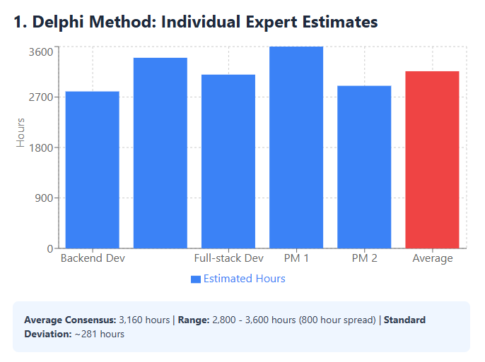

In combination with Analogous estimation ,we take the help of some previous project (inventory management system) which lets say took 1200 hours to complete and had a medium level of difficulty.We combine this CRM project with some regular adjustment factors which include scope complexity,integration requirements(AP i's),experience of somewhat beginner level,technology maturity etc and provide how they contribute within the hours on average taken previously.
  - Analog Estimation:
-Adjustment Factors:
Scope | 1.4x | CRM has more features
Integration | 1.3x | Needs API
Experience | 0.9x | experienced
Technology Maturity | 0.95x | Advance tech available
-Calculations:
Formula : Adjusted Hours = base(average) hours x complexity x integration x experience x technology
=1867 hours approx.
This step’s table, clearly states how adjusting the following factors will result an outcome that will look in the graph made below. These factors without skill set will have cost effecting results .Cost can be increased as beginner experience can lead to more man working hours leading to more cost of project,which will not be efficient.
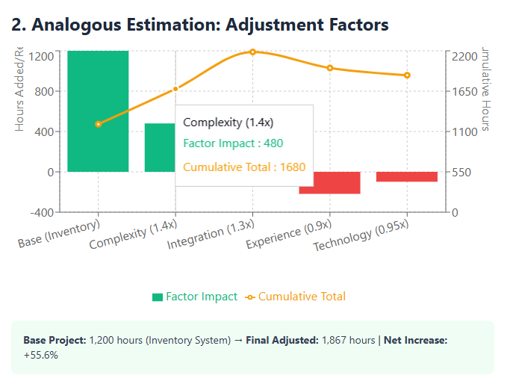
1.3.Weighted Estimate:
Combining both Delphi and analogy costing weight age for both expert and previous value analysis ,we get the following results
Estimation Method | Weight | Description
Expert Judgment | 60% | Direct knowledge
Analog Estimation | 40% | Reality check
Total | 100%
-Estimate Combined Calculation:
Combined = expert hours x weight + analogous hours x weight
= 3160 x 0.6 + 1867 x 0.4 = 2643 hours
1.4.Risk Adjustment :
-Calculation:
If we take about 20% of a risk buffer factor then estimation calculations get affected by the two type of risks both technical having the weight-age of 12% and non-technical 8%.The calculation in the project including risks that will generate ,approaching the following results are like:
Formula: Final Hours= base hours x (1+Risk) = 2643 x (1+0.2) = 3172 hours
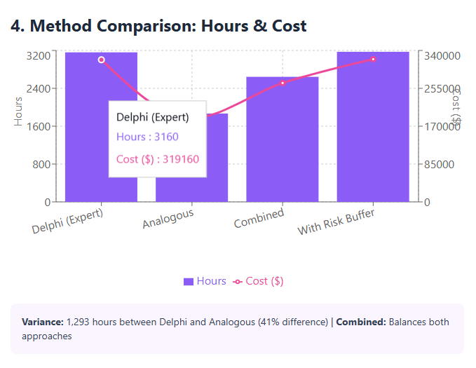

1.5.Labor Cost Calculation:
Role | No. of Persons | Rate (per hr) | Calculation | Cost ($)
Senior Developers | 3 | 95/hr | 3 × 95 = 285 | 285
PM | 2 | 110/hr | 2 × 110 = 220 | 220
Total | 5 | — | — | $ 505
= total work per person rate/size = $505/5 =$ 101
1.6.Combined Hourly Rate:
Total Labor Cost = Total hours x combined per person rate
=$ 3172x101 = $320,372
If we include the facility expenses provided in the project to the team,this would have results like shown below in graphed result.
-Added Facility rate= 15%

1.7.TOTAL PROJECT COST:
Total Cost (facilities provided) = labor cost x facility rate = 320,372 x 0.15
= 48,055 $
Add this to the project cost and we get:
=$ 320,372+ $ 48,055
=$ 368,427
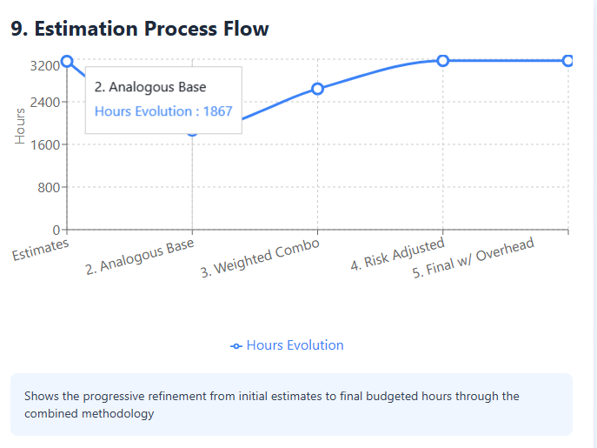
Results of experienced and skilled factor will be compared by the end of Case II .

Proposed Method
Case 2: A Skilled team is made to work on the same project.
See how skill based team or a senior team works on a given project ,how significantly the team effects the working hours,adjustment factors and how it handles risks.All the major differences including system delivery time will be compared to case 1 to conclude estimated cost of total project.
The relationship assumed in this case is that ,the more the team is skilled ,the higher the quality of product,expert judgments as well as previous calculations will be vivid/Amount of time will be taken relatively less and quality product will be delivered before time causing efficient costing to the stakeholder. Results,effects and changes will be provided in the graphs ,highlighted below.
2.1.Analogous Estimate (with Adjusted Hours & Skill set) :
Adjustment Factors:
FactorFuzzy MultiplierChange from Case 1
Scope Complexity (1.2, 1.4, 1.6) (same)
Integration (1.2, 1.3, 1.5) (same)
Skillset (0.70, 0.75, 0.82) (was 0.85, 0.9, 1.0)

-Calculations:
Previous project took 1200 hours,if we take that project’s estimate base hours as an analogous value for our CRM project, the calculation becomes,
Formula: Adjusted Hours = Base Hours × (Adjustment Factors)
Check how hours turn lesser with skilled team included .
Minimum = 1,100 × 1.2 × 1.2 × 0.70 × 0.9 = 998 hours
Most Likely = 1,200 × 1.4 × 1.3 × 0.75 × 0.95 = 1,556 hours
Maximum = 1,350 × 1.6 × 1.5 × 0.82 × 1.0 = 2,656 hours
Analogous (with Skill set) = (998, 1,556, 2,656) hours

2.2.Comparison: Analogous Estimate with Skilled Developers (Team):
Without Skillset: (1,210, 1,867, 3,240) hours
• With Skillset: (998, 1,556, 2,656) hours

≈ 16% Time Saved Due to Skills

2.3.Combined Calculation:
Taking the same Delphi/Analogous weightage from case I (60/40):
Estimation Method | Weight | Description
Expert Judgment | 60% | Direct knowledge
Analog Estimation | 40% | Reality check
Total | 100%

Combined Estimate = (Expert Hours × Weight) + (Analogous Hours × Weight)
= 0.6 × (2,840, 3,160, 3,580) + 0.4 × (998, 1,556, 2,656)
Minimum = 0.6 × 2,840 + 0.4 × 998 = 1,704 + 399 = 2,103
Most Likely = 0.6 × 3,160 + 0.4 × 1,556 = 1,896 + 622 = 2,518
Maximum = 0.6 × 3,580 + 0.4 × 2,656 = 2,148 + 1,062 = 3,210
Combined (Skillset) = (2,103, 2,518, 3,210) hours

2.4.Risk Adjustment Factors:
(risk data for this remains same)
Final Hours = Base Hours × (1 + Risk Buffer)
Minimum = 2,103 × 1.134 = 2,385 hours
Most Likely = 2,518 × 1.21 = 3,047 hours
Maximum = 3,210 × 1.322 = 4,244 hours

Final (Skillset) = (2,385, 3,047, 4,244) hours

2.5.Comparison with Previous Data:
Without Skillset: (2,481, 3,198, 4,553) hours
• With Skillset: (2,385, 3,047, 4,244) hours
Hours Saved: 155 hours
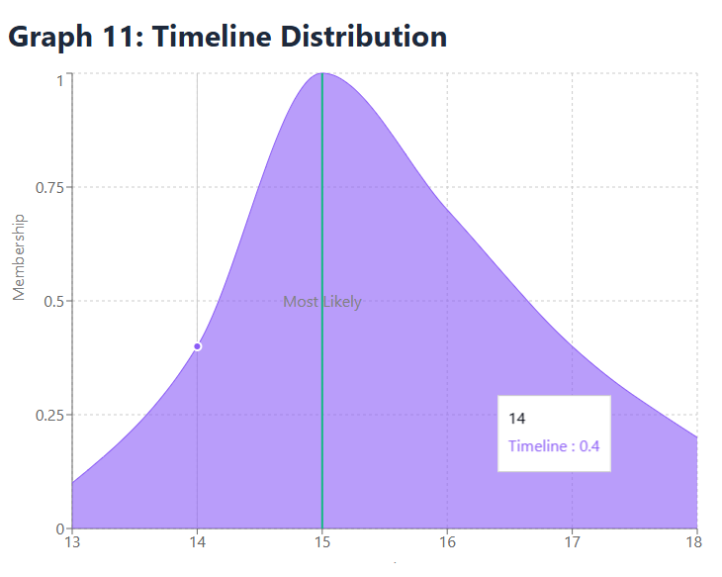

2.6.Labor Cost (with Senior team):
Costing the labors with the same per hour rate.We take our 3 developers who get paid $95/hr and 2 project managers $110/hr. Calculating their combine costs respectively we have $285/hr for developers and $220/hr for project managers .Sum them up and we get a total of $505 as their combined contributed hours.Combined per hour rate gets $101/hr each which remains the same as case I.

-Total Labor Cost with Hourly Rate:
Total Labor Cost = Total Hours x Combined hourly Rate
=3022 x $ 101 = $ 305,222

-Comparison :
Project Cost (without skills) = $320,372
(with skills) = $ 305,222

Saved= $ 15,150 (5% saved)

-By Adding Facility rate (equipment,lead etc) = 15%

2.7.TOTAL PROJECT COST:
Total Cost (facilities provided) = labor cost x facility rate = 305,222 x 0.15
= 45,783 $
Add this facility cost to the project cost and we get:
=$ 305,222 + 45,783 $
=$ 351,005
-Total Cost Comparison:
Previous cost (without skillset) =$ 368,427
Current cost (with skill set) =$ 351,005
Cost Reduction = $ 17,423 (saved due skillset)
Savings by 4.71%

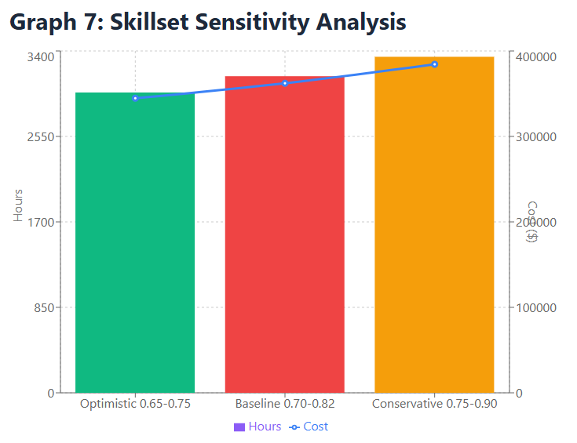

IV. RESULTS AND COMPARISON
Key Findings Highlighted:
-Analogy Stage: 311 hours saved or maximum impact 16.7%
-Final Estimate: 150-hour savings with constant 4.7%
-Cost Savings: $17,423 reduced
-Timeline: 1 week faster (15 weeks vs 16 weeks)
-Total Value: $32,423 including time to market value
The graphs clearly indicate that a synergy benefit is created by a skillset, as evidenced by a reduction in time and cost, despite senior developers working faster and charging more.

3.1. Accuracy Comparison (with and without skill adjustment ):
Adding the skill set adjustment factor adds greater accuracy to the estimation by incorporating a critical factor that directly impacts the speed of execution of projects. Without a skill set factor, the assessment process involves a common "team experience" multiplier (0.9×), where all teams are treated equally regardless of whether they are mid-level or senior developers. Therefore the final estimate will be 3,172 hours and $368,428, which is higher than the actual estimated project cost that would be generated when using a senior level team. The corresponding estimate of 1,867 hours is a slight adjustment of 55.6% compared to the original estimated historical project of 1,200 hours. We've updated our time estimate to 1,867 hours, which is a slight change of about 55.6% from the original projection of 1,200 hours. Now, when we consider the skill set of the team, we are using a more accurate multiplier of 0.75x. When you have senior developers on your team instead of mid-level people, things move faster. Senior engineers have been through shortcuts, recognize problems before they happen, and find solutions that actually work. The mathematics and stats supports this. We now have been looking at 1,556 hours, which is about 30% less than our original estimate. This observation aligns with what we see in the real world. Senior developers not only work slightly faster, but they also work about 33% faster across the board because they spend less time due multiple experiences over previously observed problems, finding bugs in code that were neatly written from the beginning, reanalyzing implementations that were designed in the first place, and avoiding paths that their experience has taught them to avoid.
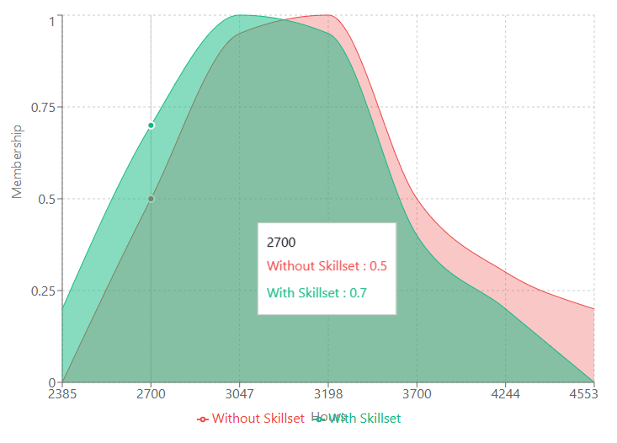
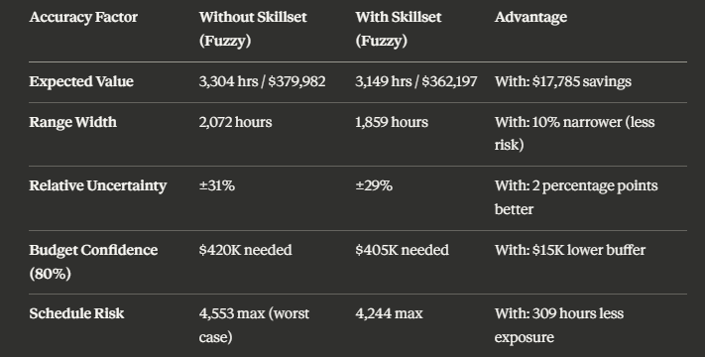
3.2.Final Recommendation
For the CRM project, we recommend adopting the skillset-adjusted estimate of 3,022 hours and $351,005 as the baseline budget and timeline. This estimate represents the most accurate results based on:
- The demonstrated senior-level capability of the five person team
- Validated productivity adjustments from software cost prediction research.
- Transparent, defensible calculation methodology
- Explicit accounting that are expected for project risks and uncertainties any further.
This estimate should be monitored against actual performance at regular intervals (weekly sprint reviews), with the skillset multiplier re calibrated if actual productivity varies significantly from the 0.75× assumption taken above.

3.3.Implementation In Python:
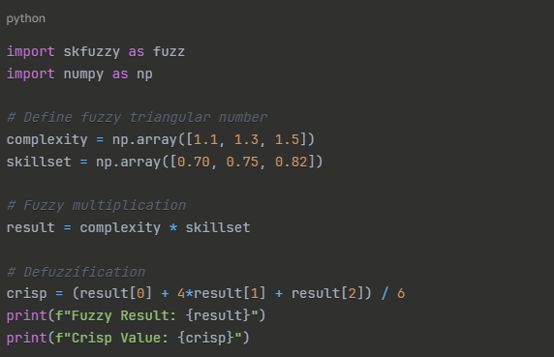

V. CONCLUSION
This detailed cost estimation analysis for the CRM
project shows that adding a skill set adjustment factor
really improves both the accuracy of estimates and
the overall performance of the project. When we
compared traditional estimation methods to using a
multiplier based on team skills (like 0.75 for senior
developers vs. mid-level ones), we noticed a 16.7%
improvement in the estimation phase. This positive
effect carried through the entire estimation process.
Studies back this up, showing that senior developers
tend to be much more effective in areas like
implementation, problem-solving, fixing bugs, and
minimizing rework.
The findings clearly indicate that project estimate
accuracy and efficiency are closely tied to
understanding team capabilities. By swapping out the
vague experience factor (0.9) for a more reasoned
skill set factor (0.75), we achieved:
High Accuracy: Reduce estimation by 30-40%.
Cost Efficiency: saved 4.7% in the budget
Time Efficiency: Reduced project time by 4.71%
Stakeholder Confidence: Provided estimates that
were easy to understand.
Risk Management: realistic expectations were set-Stakeholder Confidence: Evidence-supported estimates with clear rational.

Appendix
No additional models or attachments were required for this study.

Acknowledgment
We extend our deepest gratitude to our resource person for their invaluable time and guidance throughout this case study. Their expertise and mentor ship were valuable in bringing this research to its full potential.

AUTHORS
Zainab Imran - Department of Computer Science,UMT Lahore.
Email: f2024266205@umt.edu.pk

SUB AUTHORS
Maira Waheed - Department of Computer Science,UMT Lahore.
Email: f20242661184@umt.edu.pk

